*SAFE CARZ*

*INSURANCE*

USER GUIDE

|  |  |
| --- | --- |
| Batch Information | |
| Faculty | Sir Taha Abbas |
| Coordinater | Miss Maham Haider |
| Batch No | 2409E2(T,T,S) |

|  |  |
| --- | --- |
| E Project | Insurance |
| Group | C |
| Group Members | |
| ID Number | Name |
| Student1605829 | KASHAF AKHLAQ .(Leader) |
| Student1605688 | MUHAMMAD FARAZ . |
| Student1605995 | ZILL E HUMA . |
| Student1605660 | MUHAMMAD ABDUL REHMAN . |

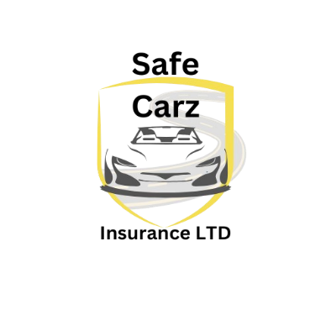

MAIN PAGE :



NAVBAR:

Using the navbar,the user can navigate through various Insurance.

We have total 7 items in Navbar ,which are further classified as:

* HOME
* BUSSINESS INSURANCE
* PERSONAL INSURANCE
* CAREERS
* CONTACT US
* ABOUT US
* LOGIN

We Have used the dropdown menu for the *BUSSINESS INSURANCE*

And *PERSONAL INSURANCE*  which are further classified like:

**BUSSINESS INSURANCE**

* Property Insurance
* Marine insurance
* Engineering Insurance

**PERONAL INSURANCE**

* Travel Insurance
* Health Insurance
* Car Insurance

HOME PAGE:

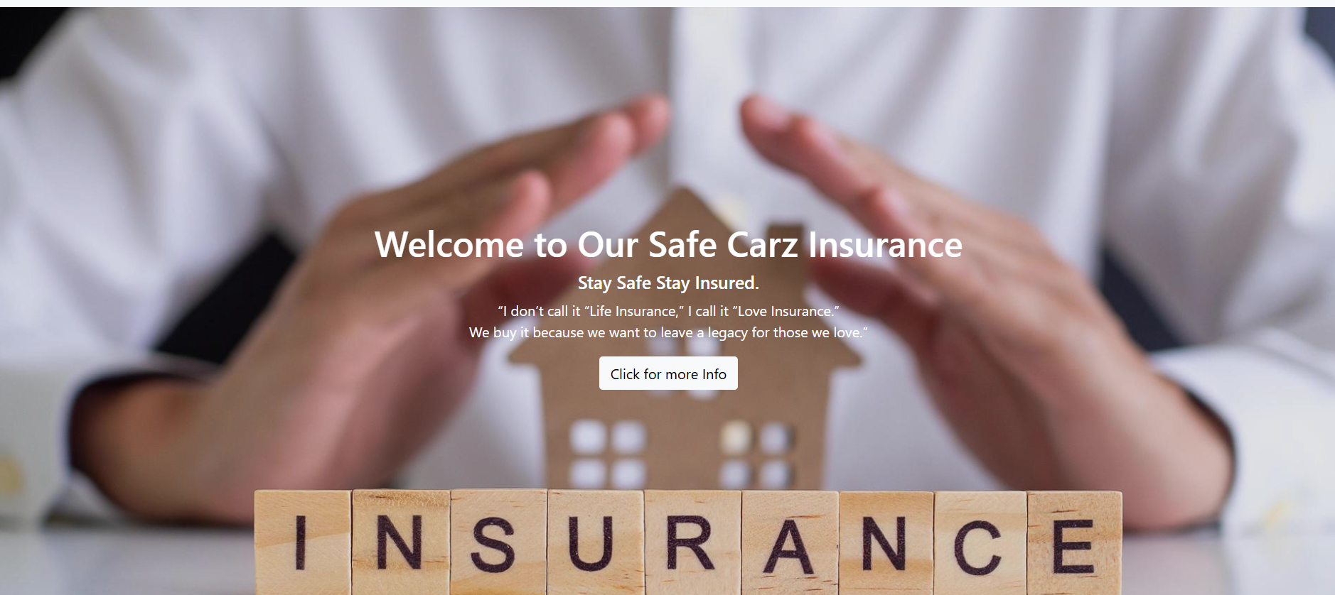

This is home page of our website .This page provide Information about

Our business page ,services and products .

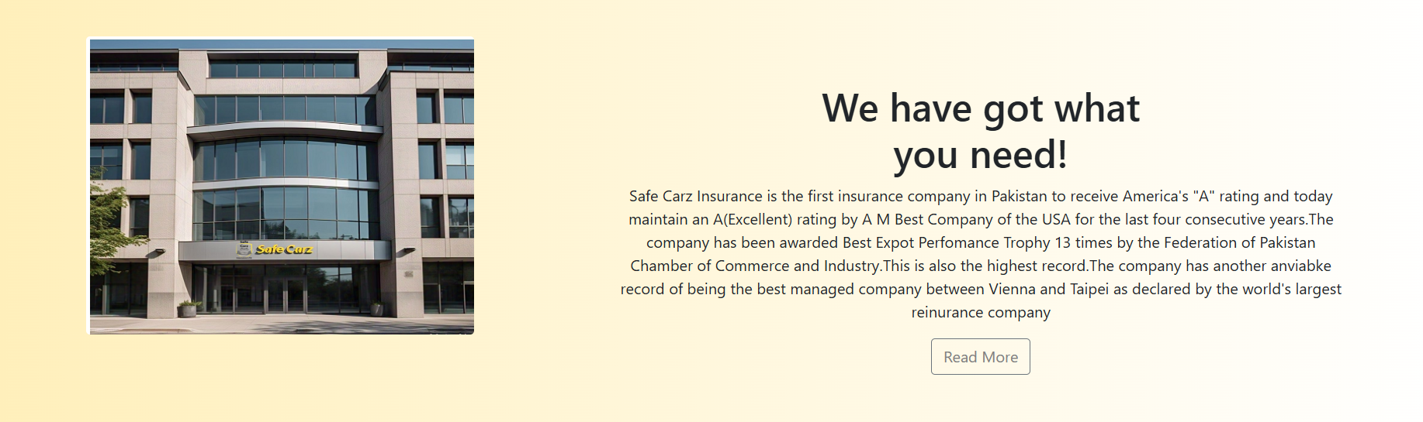

On clicking the Read more so you can see the more information about the safe carz Insurance.

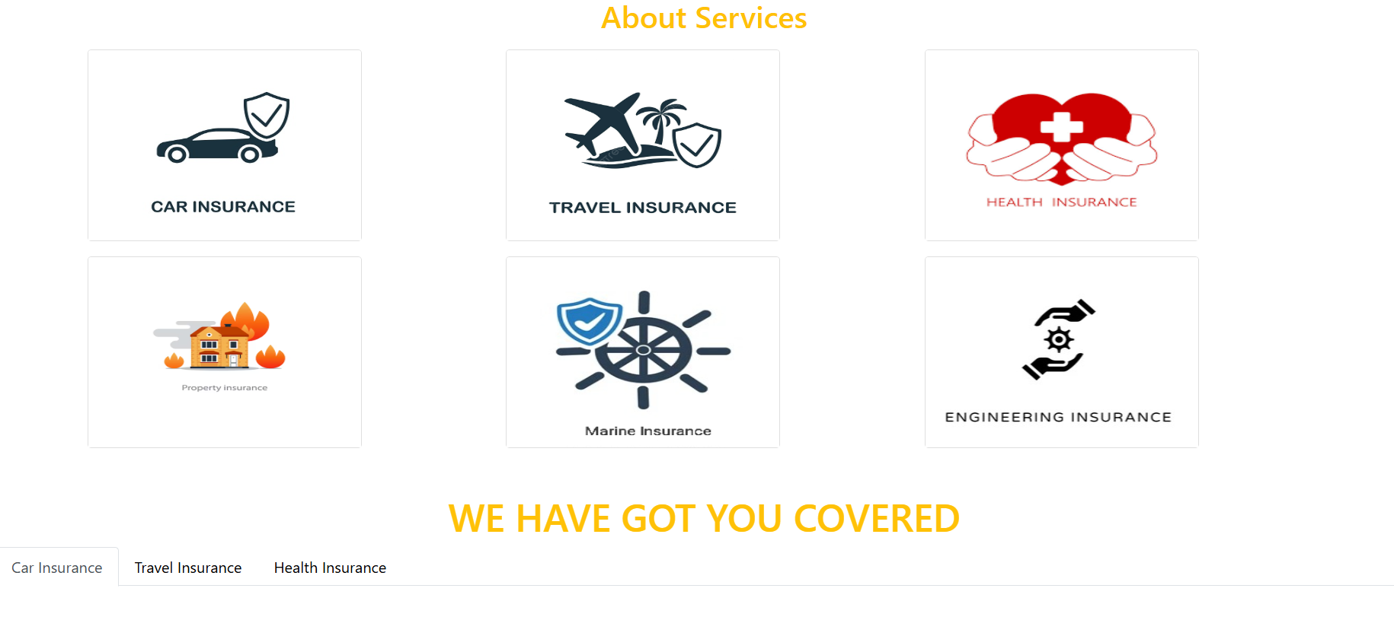

On clicking you can visit more about insurance plans

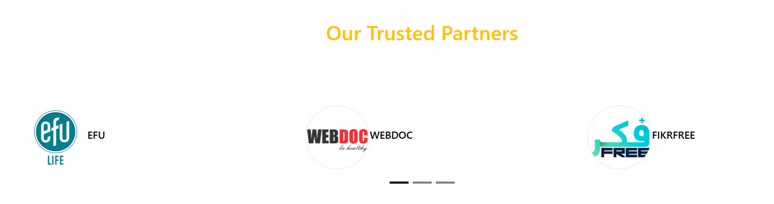

OUR PARTENERS:

By clicking on this you can visit our partners website.

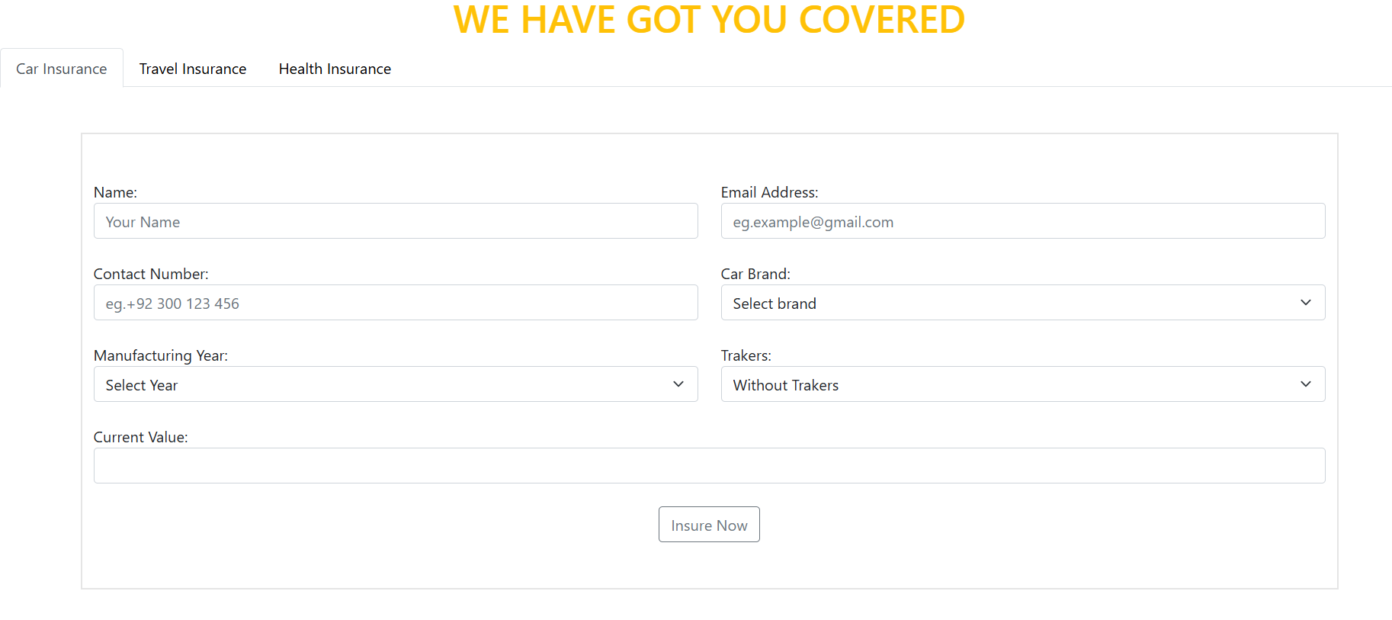

Now here , The user put their information and give requested detail after which clicking on the Insure now.then the user will be insured.

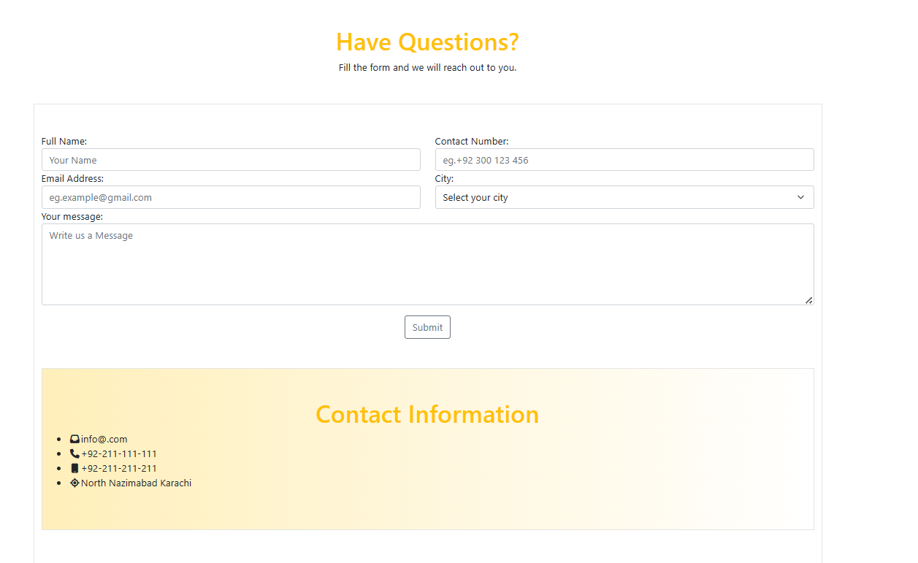

We make also another form which for if you have any question

Or concern about our Insurance services ,so the user fill out the foam and submit to us .

We are provided our contact number if the user face any kind of problem so we providing you with best possible support.

Whether you have question about our policies ,claims or anything else we’re here to help

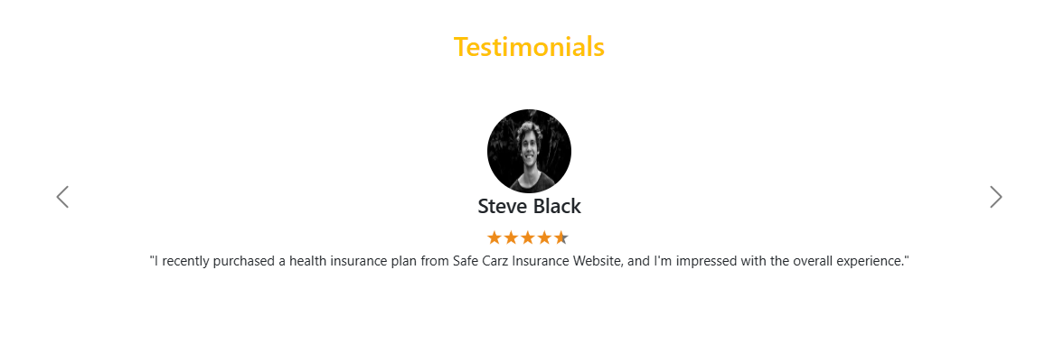

These are some opinions of our users about our website.



Now you can download pdf file of terms of insurance and plan of insurance. Or you can rate our website.

PERSONAL INSURANCE PAGE:

* Personal Insurance Page

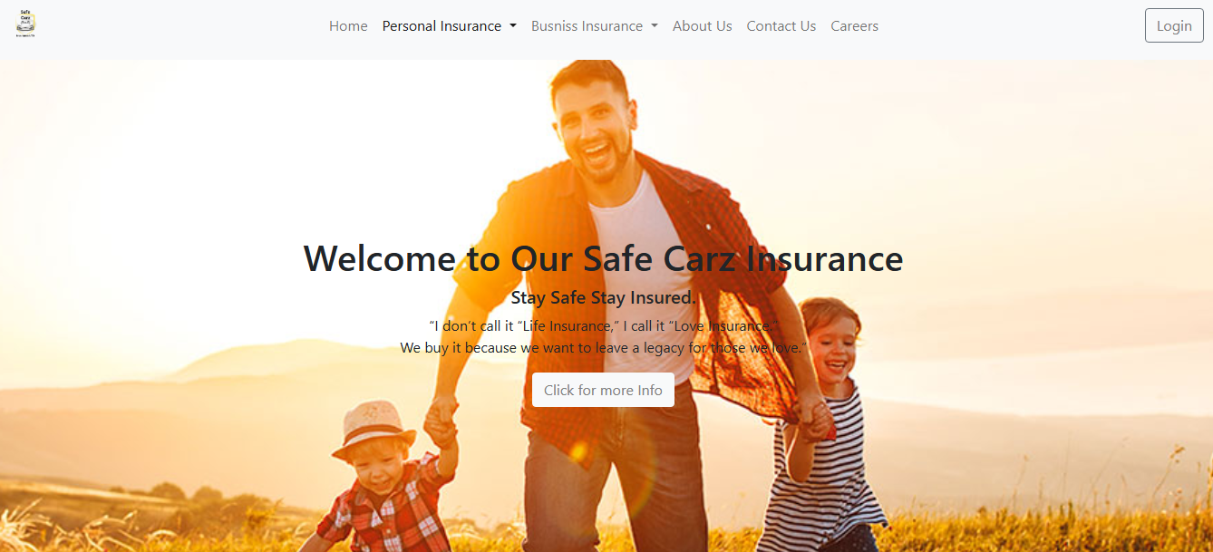

This is personal insurance of our safe carz Insurance .Personal insurance provides financial protection to individuals and their families against accidents ,illnesses and death.Here the user clicking on click for more info so the user get more info about that.

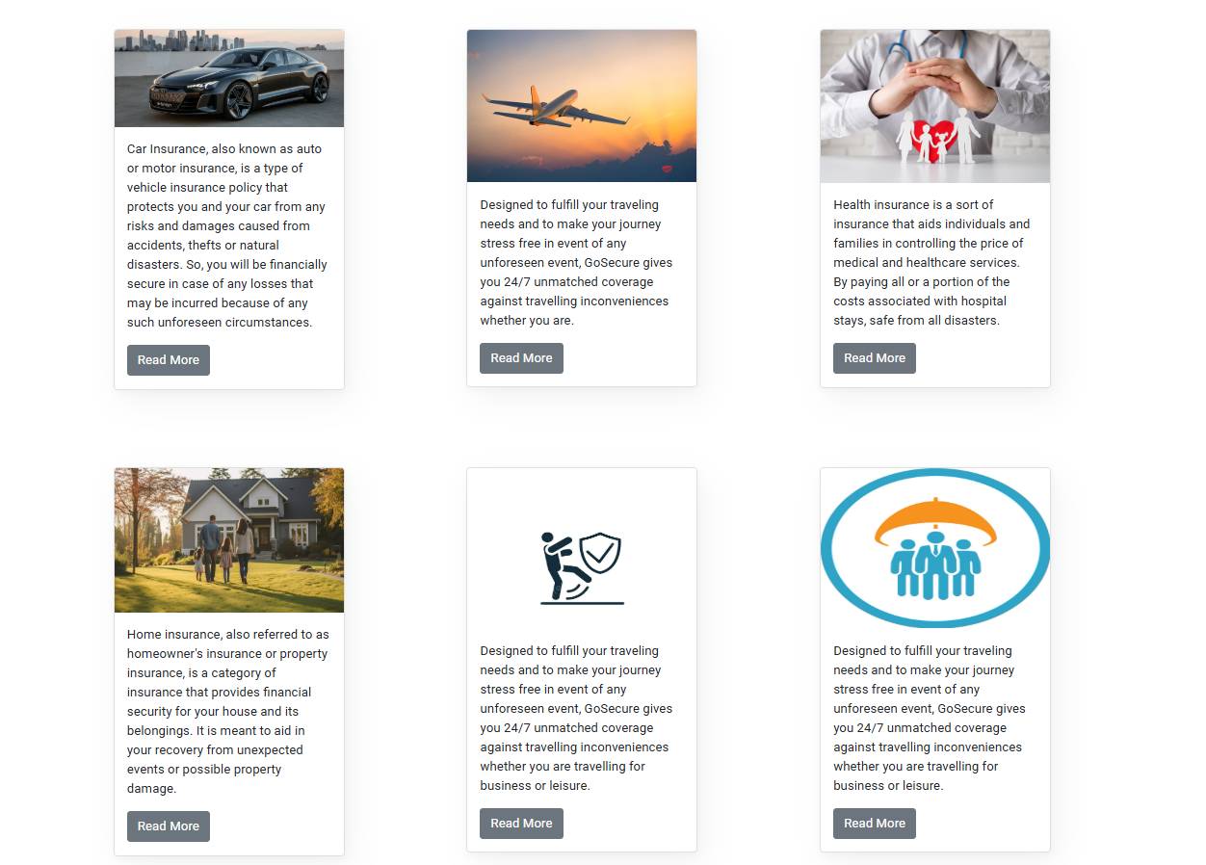

Given above the heath insurance ,car insurance, travel insurance ,home insurance if user click on read more so get more information about this.

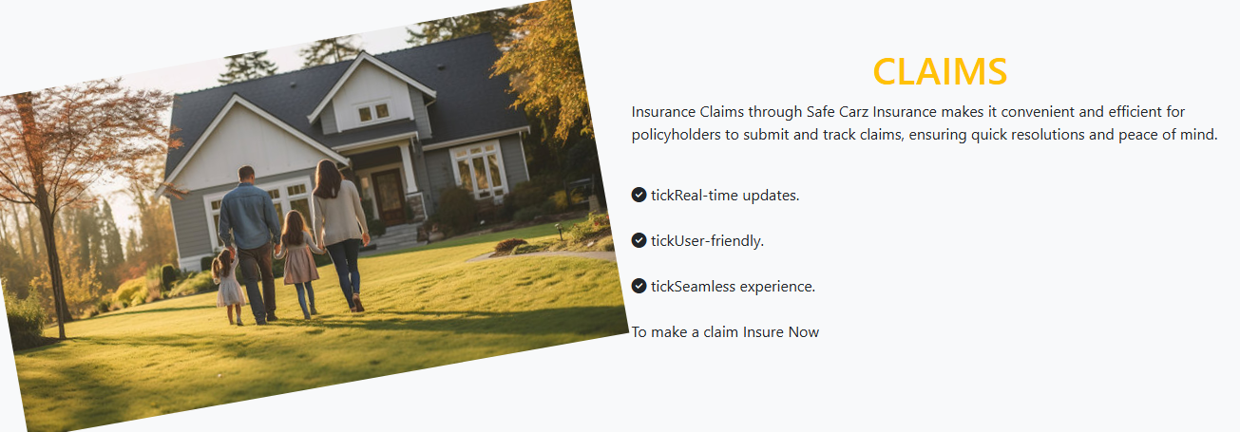

User have any question so you will asked?

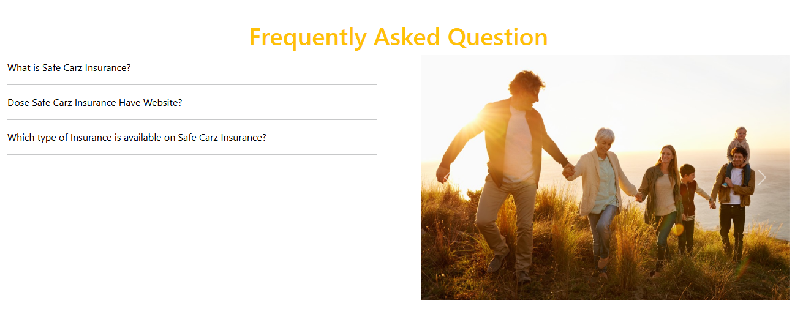

Answers of some freqwent asked question.

Car insurance:

* Car Insurance Page

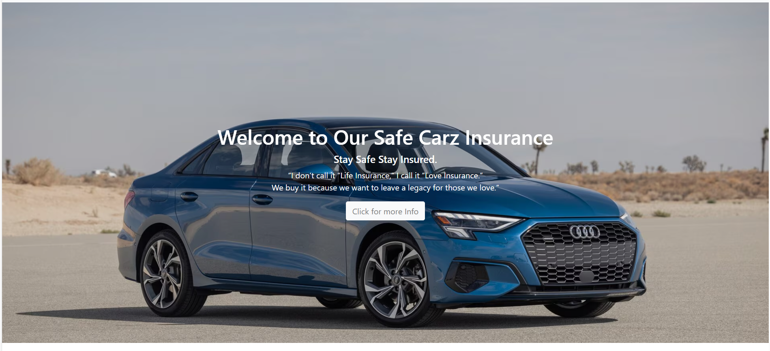

Car insurance is a type of insurance that protect you and your vehicles against financial losses in the event of an accident or the damage.If the wants to get it so user click on login

In the Log In page user can login to our website, for addition

we have done session storage work on this page, and when the user fills all details

on the signup page an account will be created.

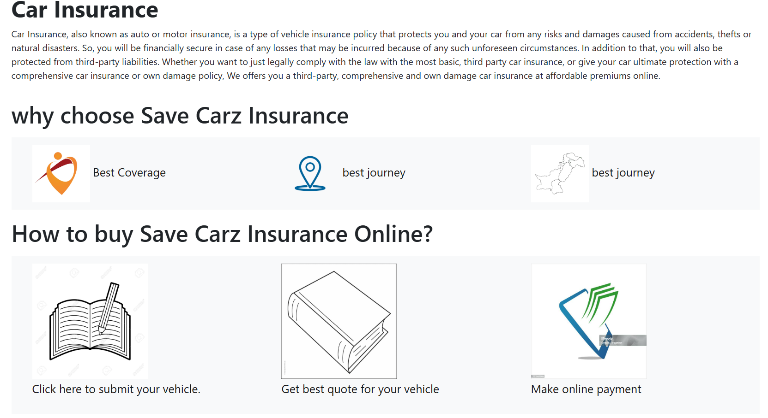

Here we are given guid how to get the save carz insurance online

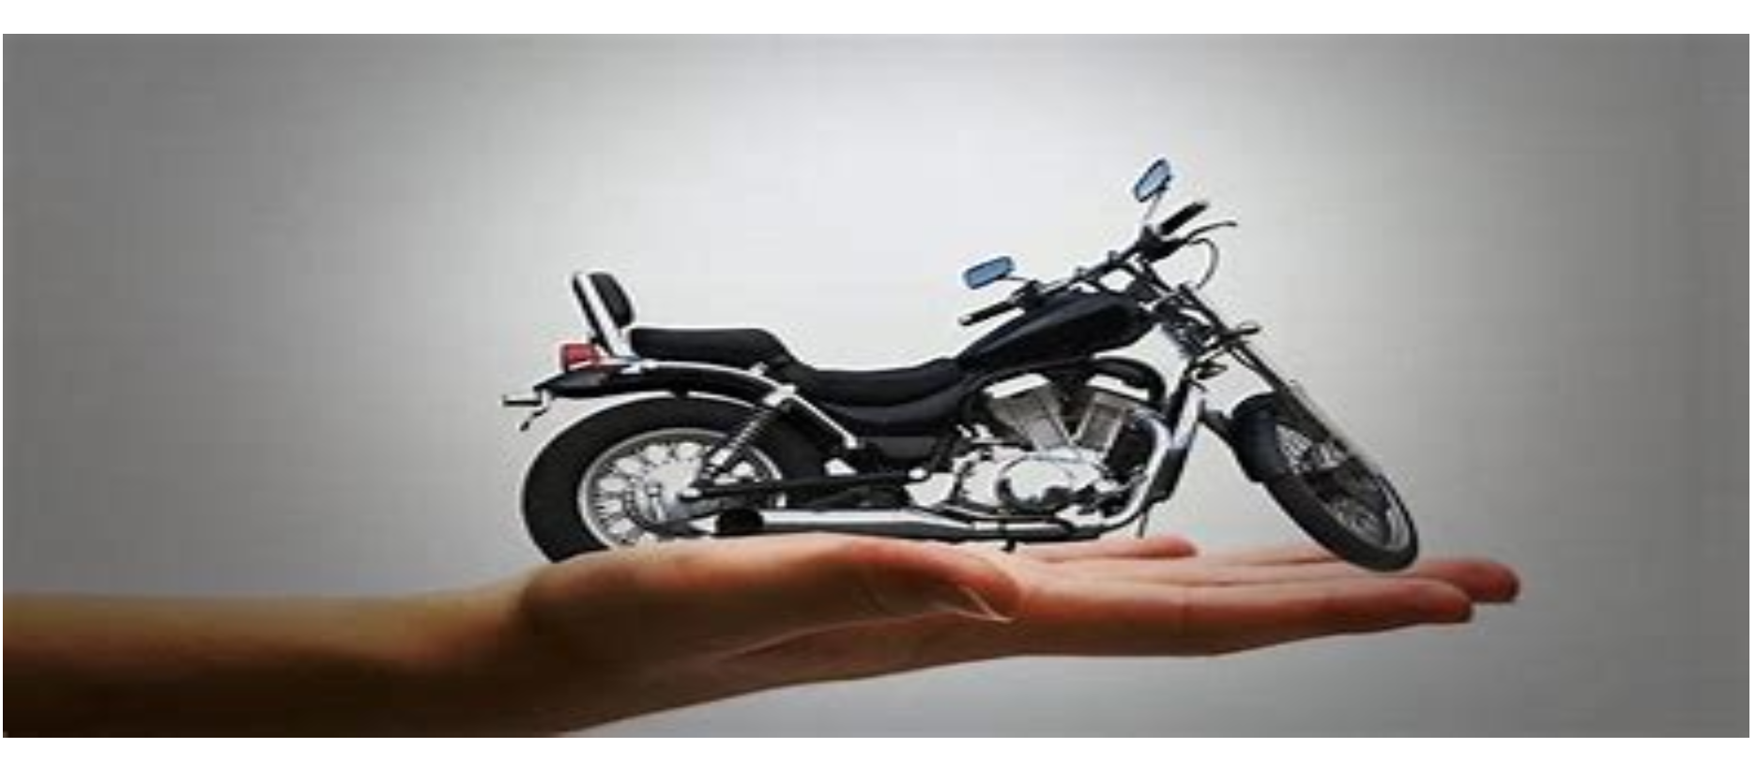

Now you can also insure you bikes at Safe Carz Insurance.

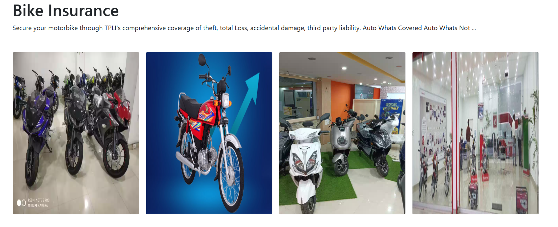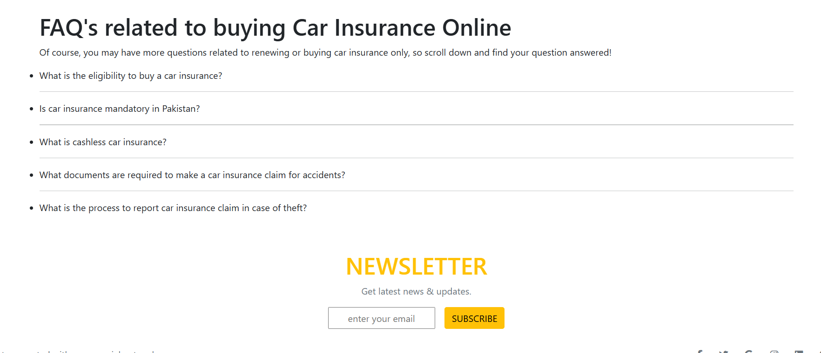

You can see our resent news.

TRAVEL INSURANCE:

Its our travel insurance page.Here the user know the about the travel insurance and easy get the travel insurance of save carz insurance

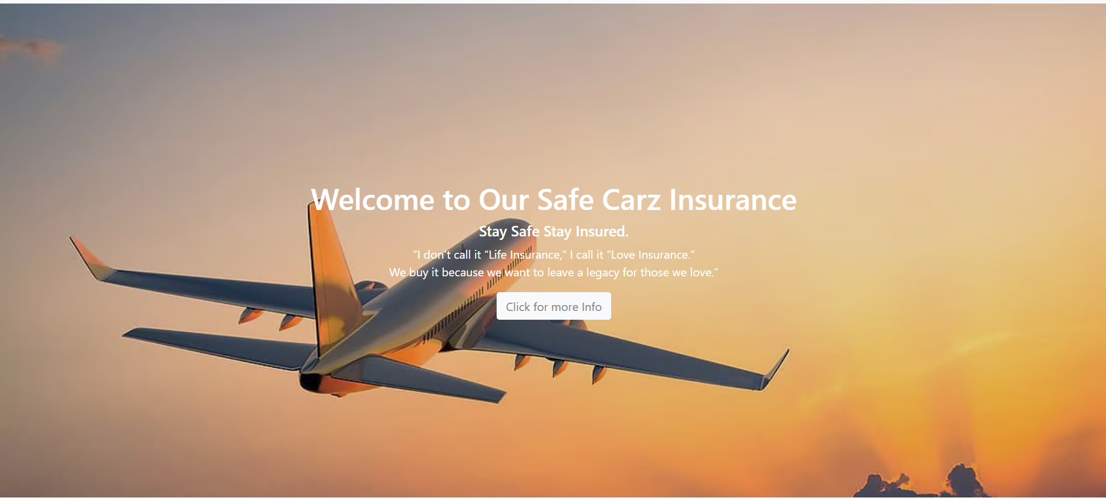 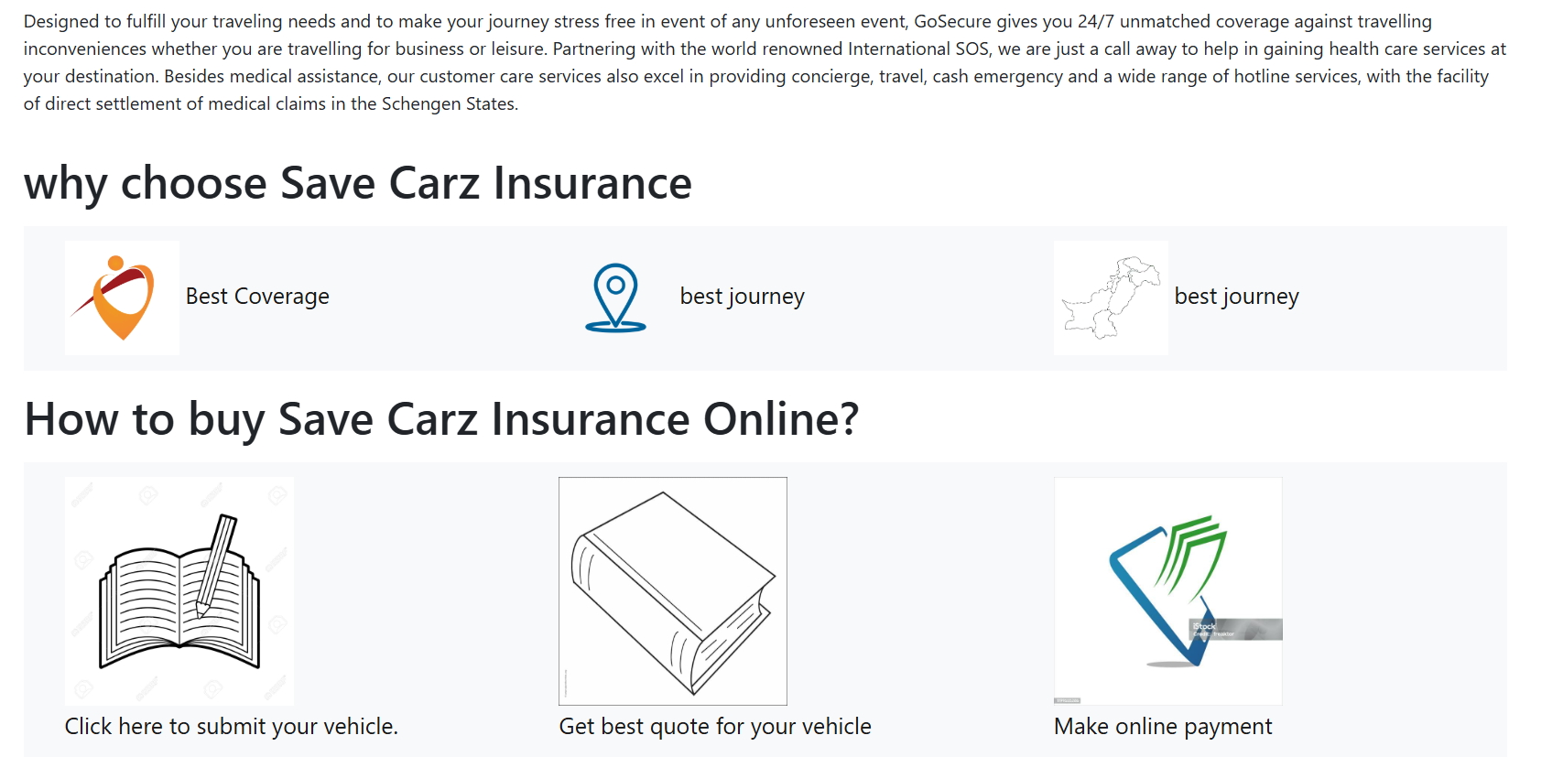

Here we are given guid how to get the save carz insurance online

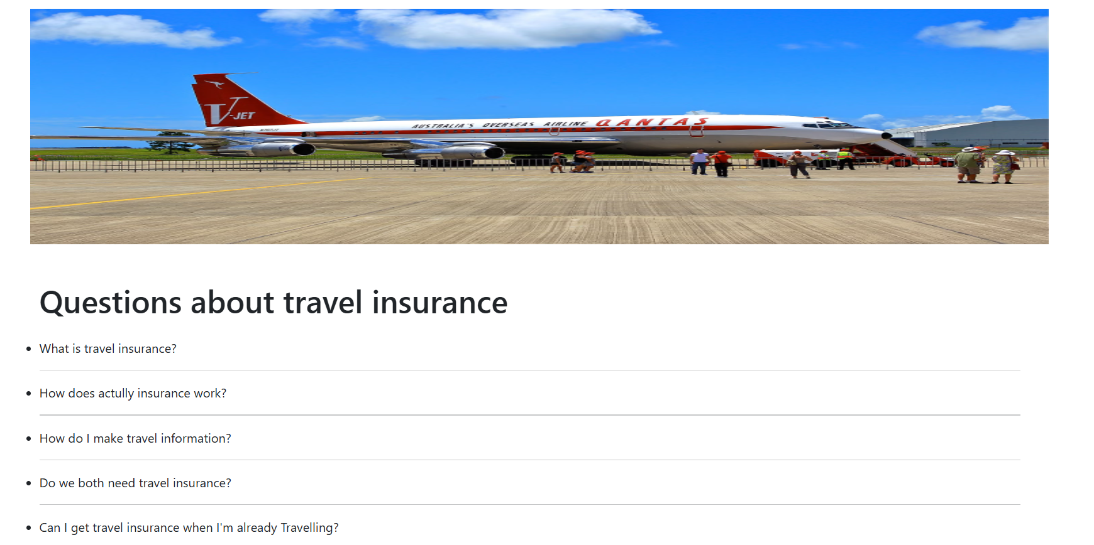

HEALTH INSURANCE:

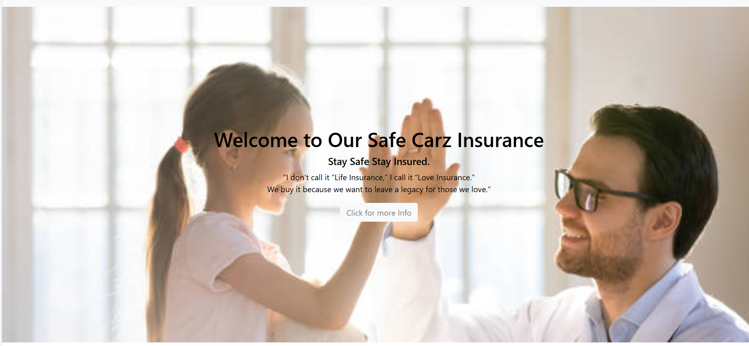

Health insurance is a type of insurance that provides financial

Protection against medical expense.It helps you cover the costs of

Hospitalization, surgery, and other medical treatment.

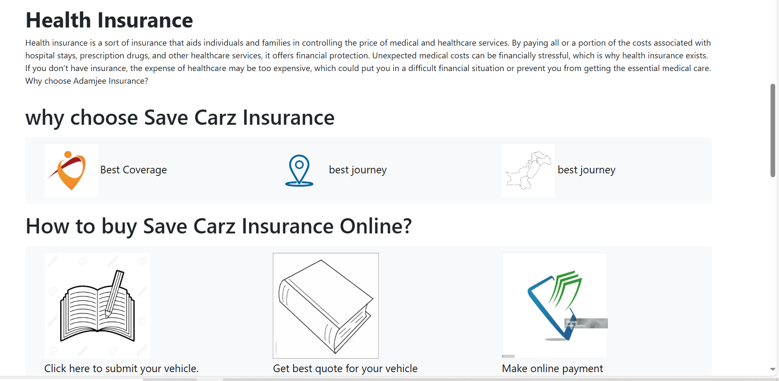

Here we are given guid how to get the save carz insurance online

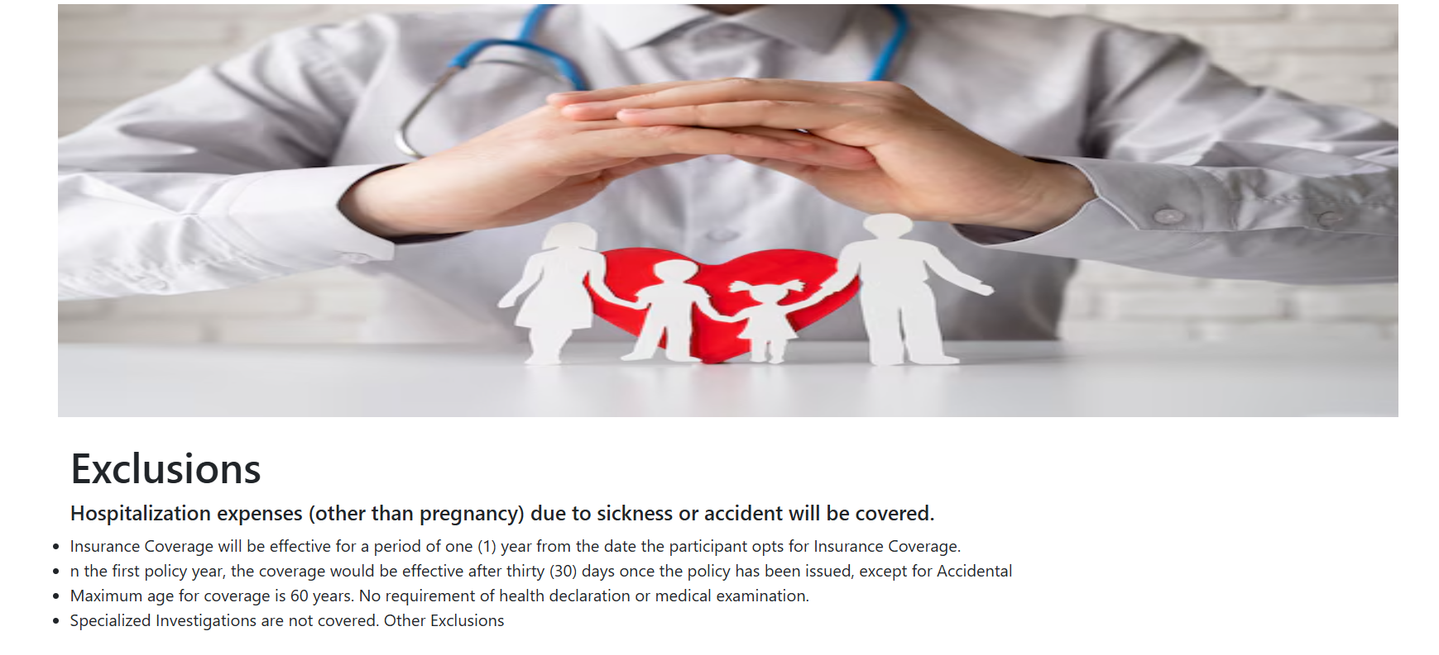

BUSSINESS INSURANCE:

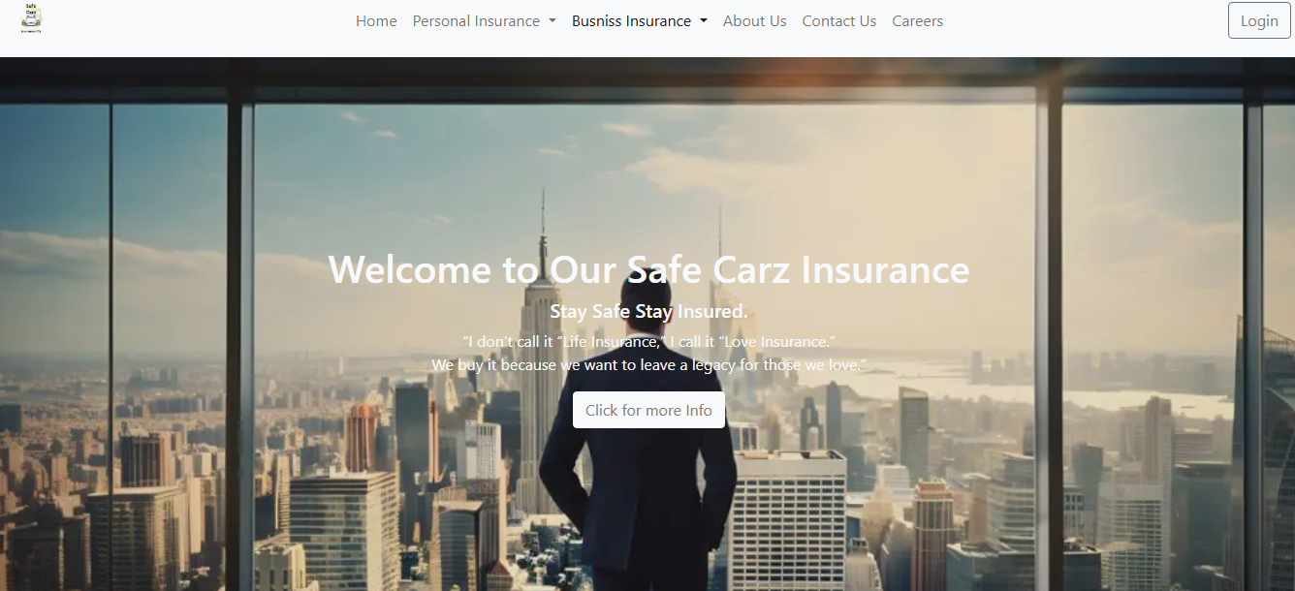  
wellcome to our bussiness insurance page will guide the user navigate and understand our bussiness insurance product.The user wants to know more so clicking on more info.

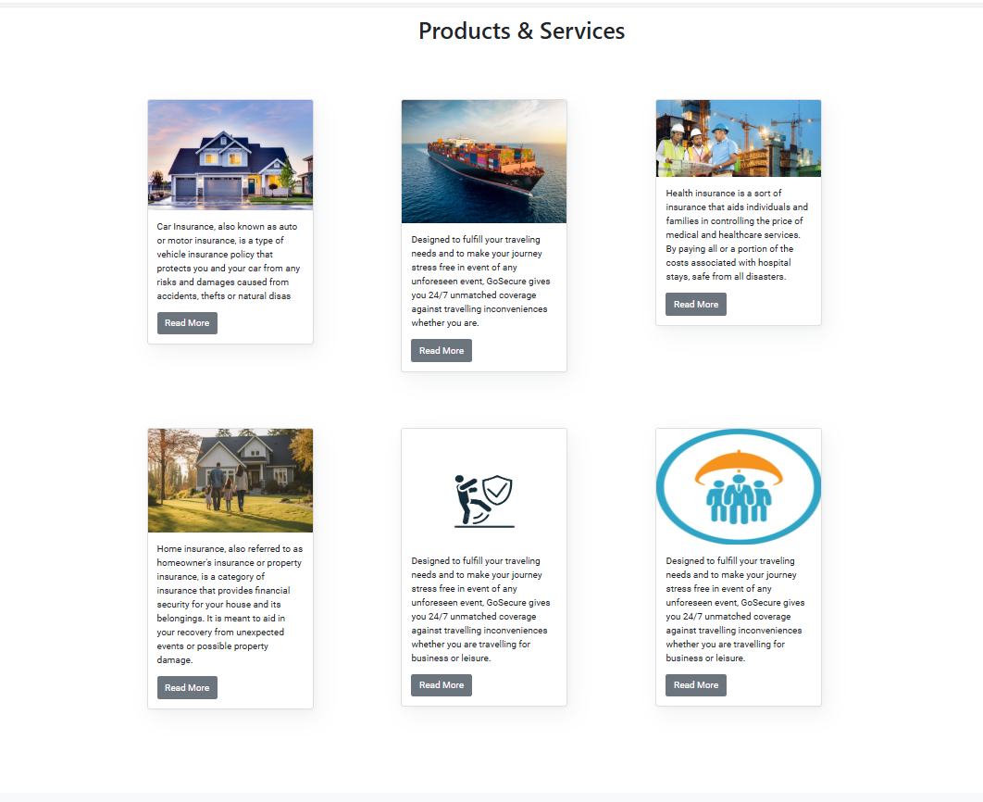

Someinsurance about business of

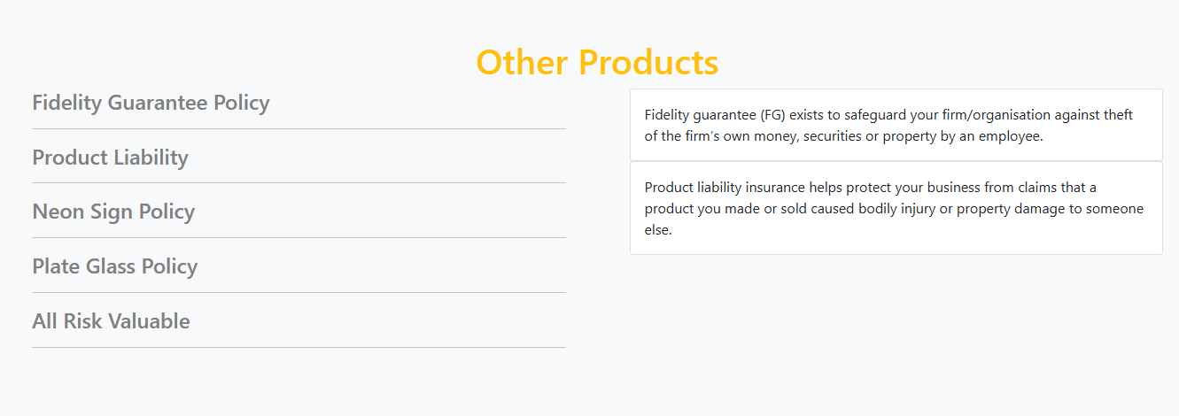This is other products if the user click on this so the user get information through slide .

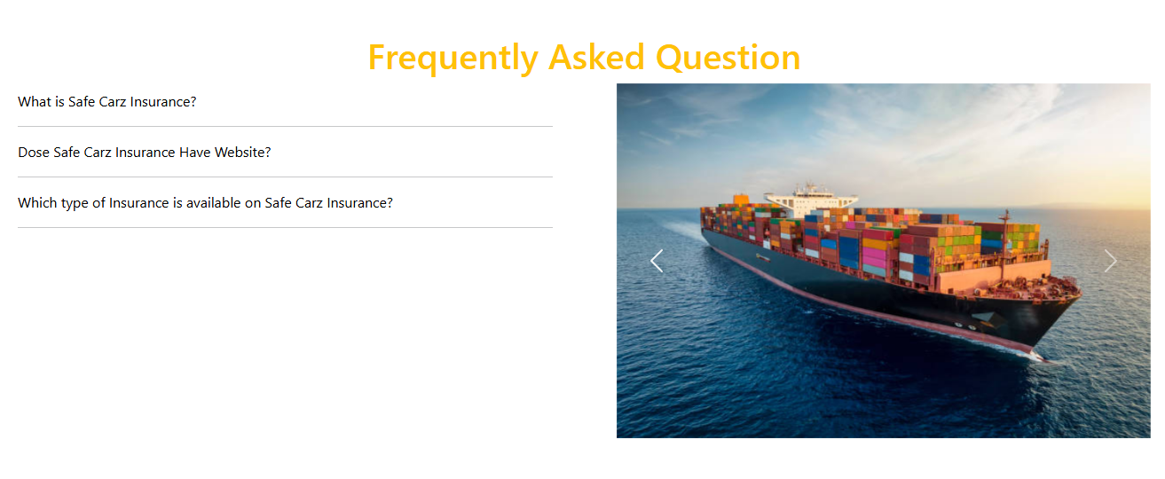

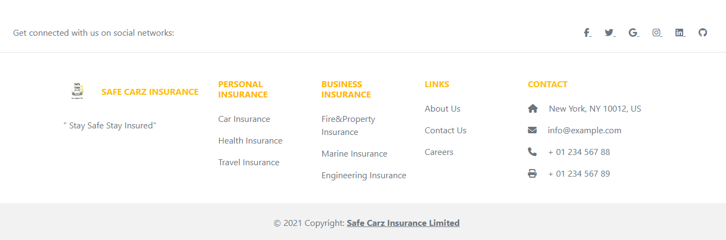

PROPERTY INSURANCE:

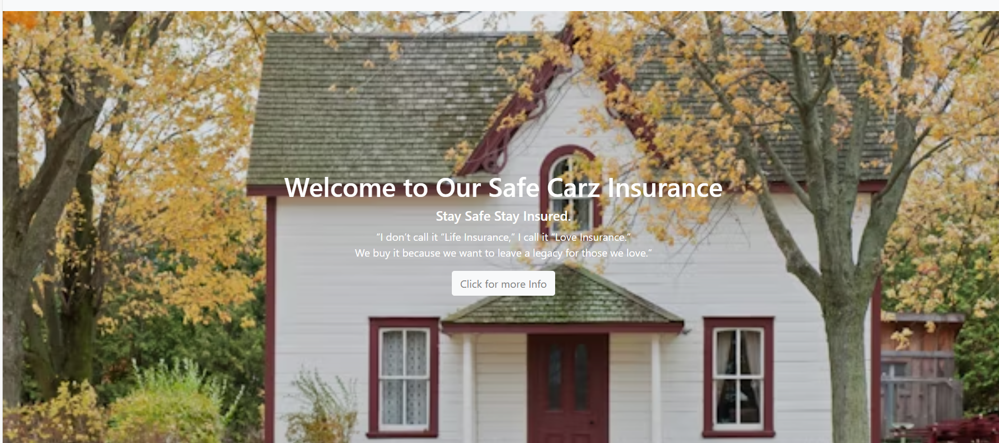

Its our property insurance page.Here the user know the about the property insurance and easy get the property insurance of save carz insurance.

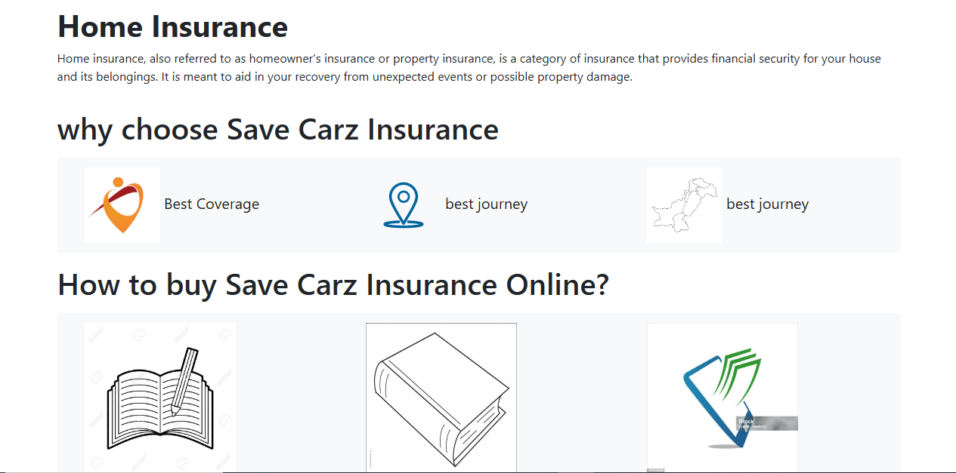

Here we are given guid how to get the save carz insurance online

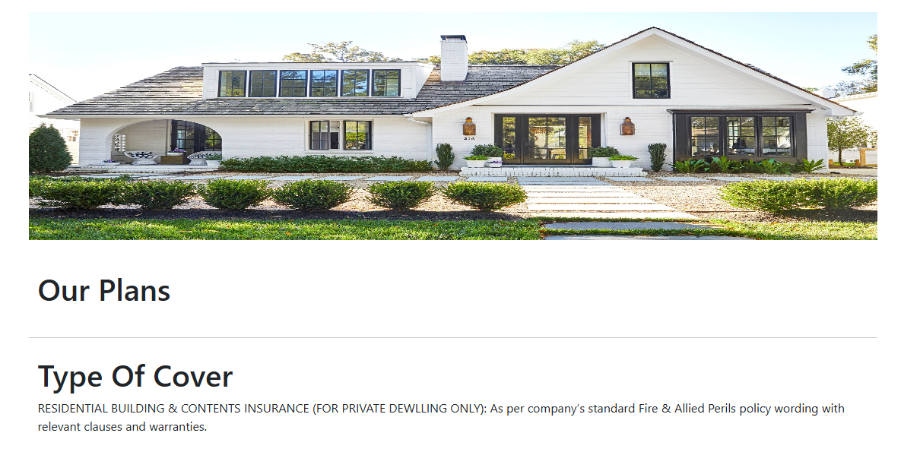

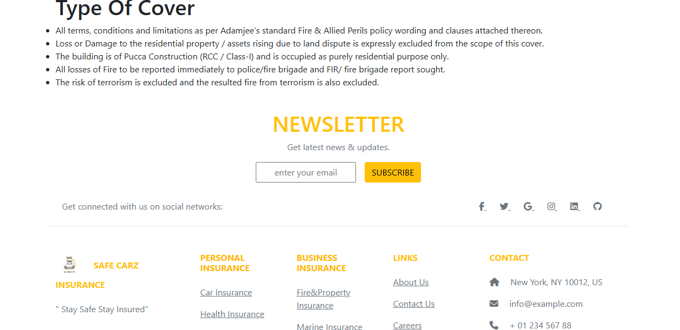

Marine insurance:

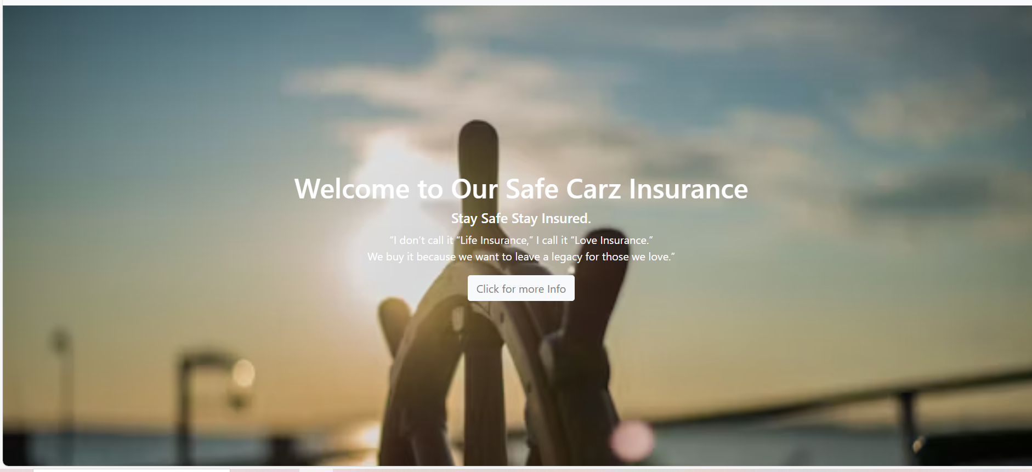

Marine insurance protects ships, cargo, and other maritime assets from risks like accidents, theft, and natural disasters during transit. Save Carz Insurance offers a simple and hassle-free process to secure your marine insurance, ensuring financial safety against unforeseen losses. Users can easily explore policy options, get instant quotes, and purchase coverage online with minimal documentation. Trust Save Carz Insurance for reliable marine protection and smooth claim settlements...

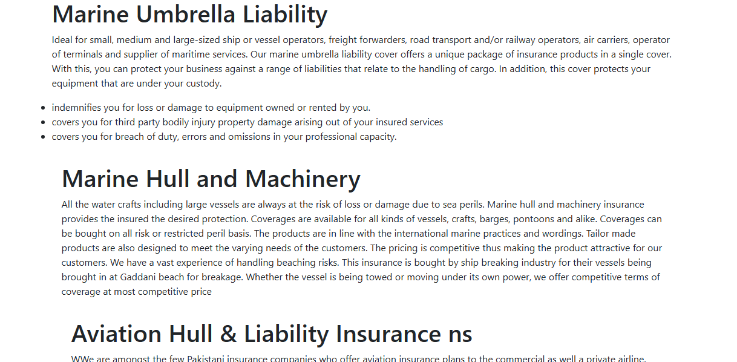

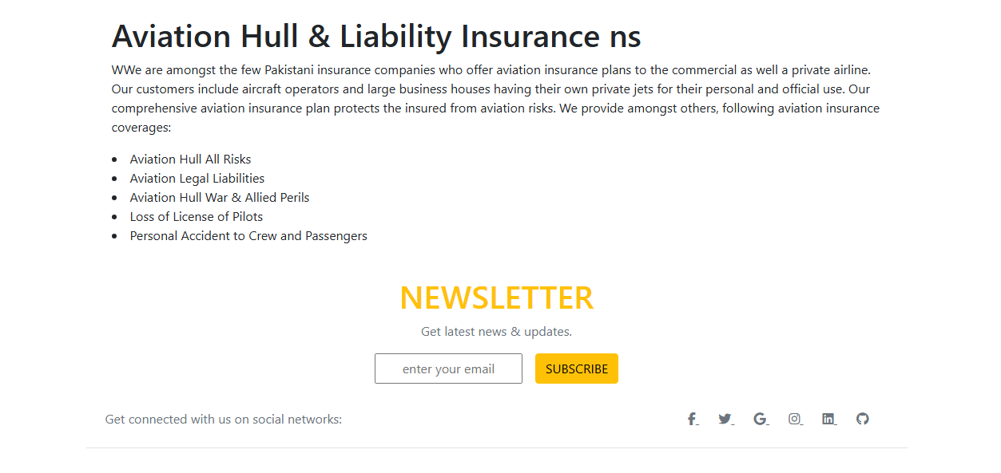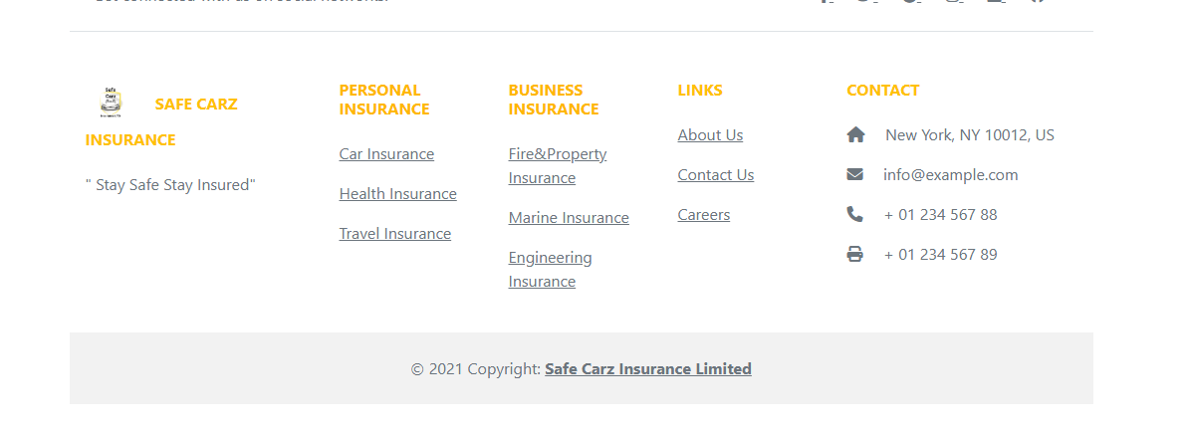

ENGINEERING INSURANCE:

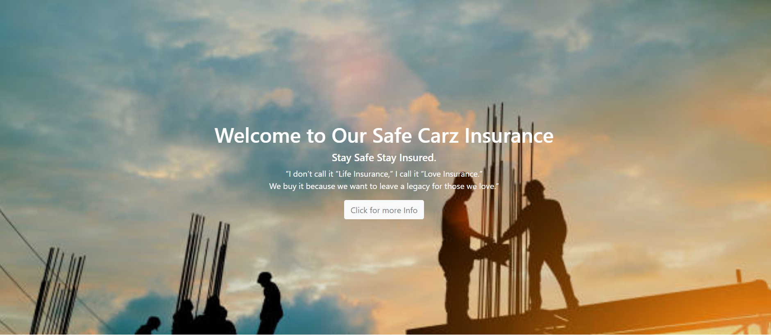

Engineering insurance provides coverage for construction projects, machinery, and equipment against risks like damage, breakdowns, and accidents. It ensures financial protection for contractors, builders, and businesses involved in engineering works. Save Carz Insurance offers tailored plans with easy claims and quick processing, securing your projects from unforeseen losses. Get reliable coverage today for a stress-free engineering experience!

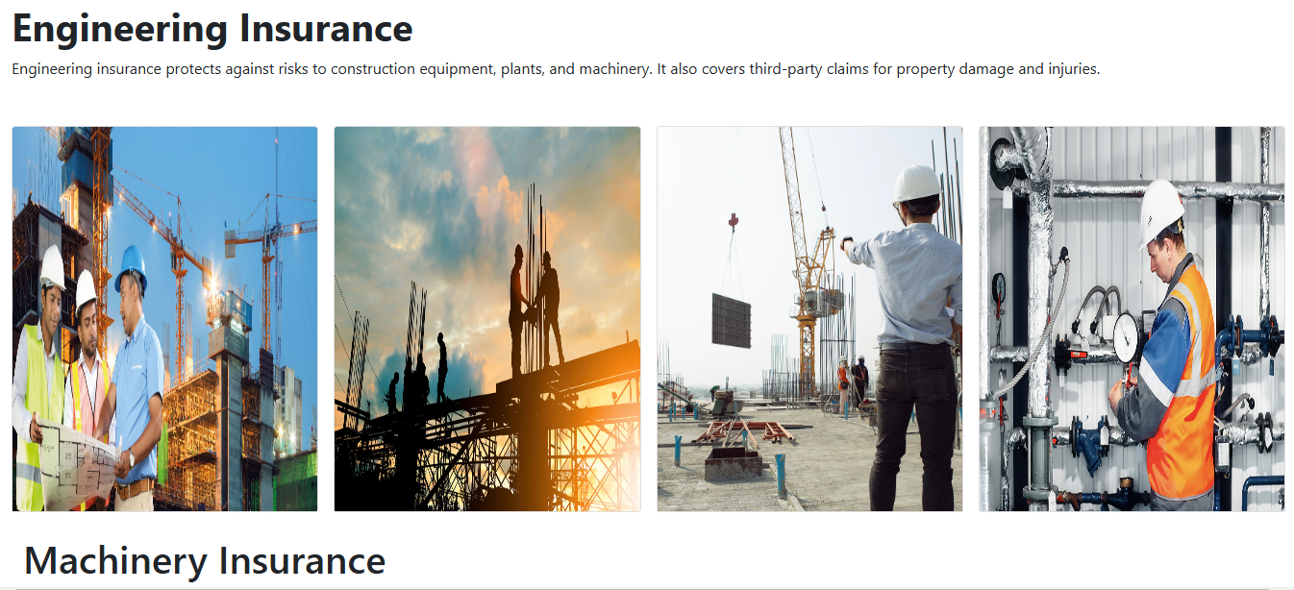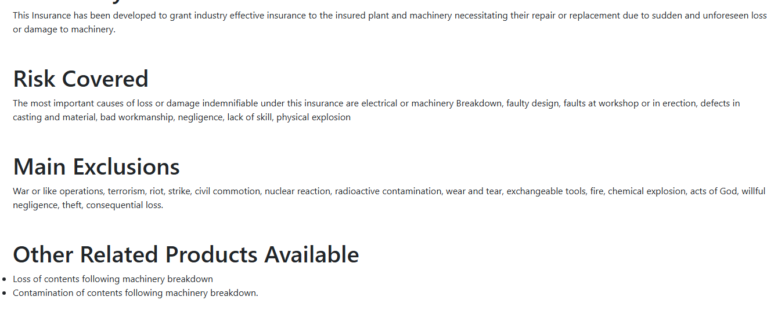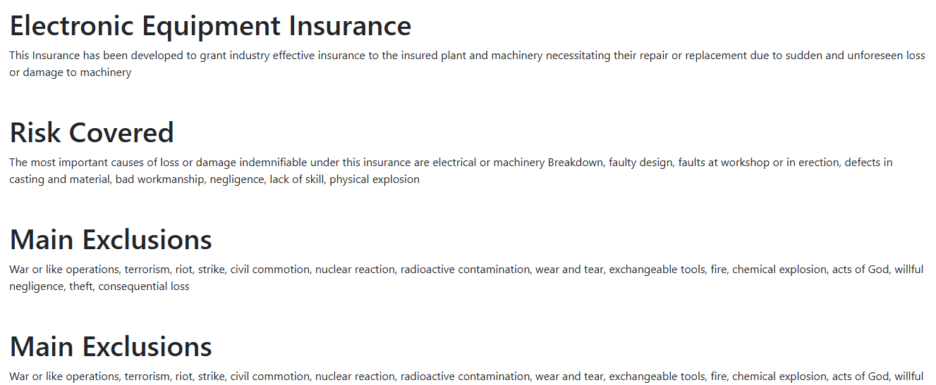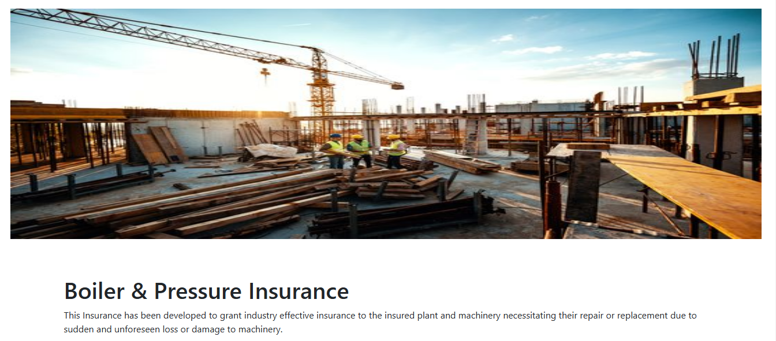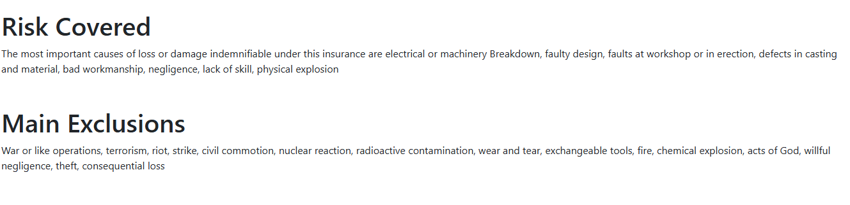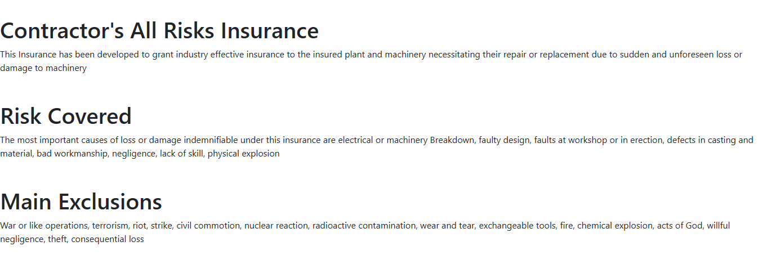

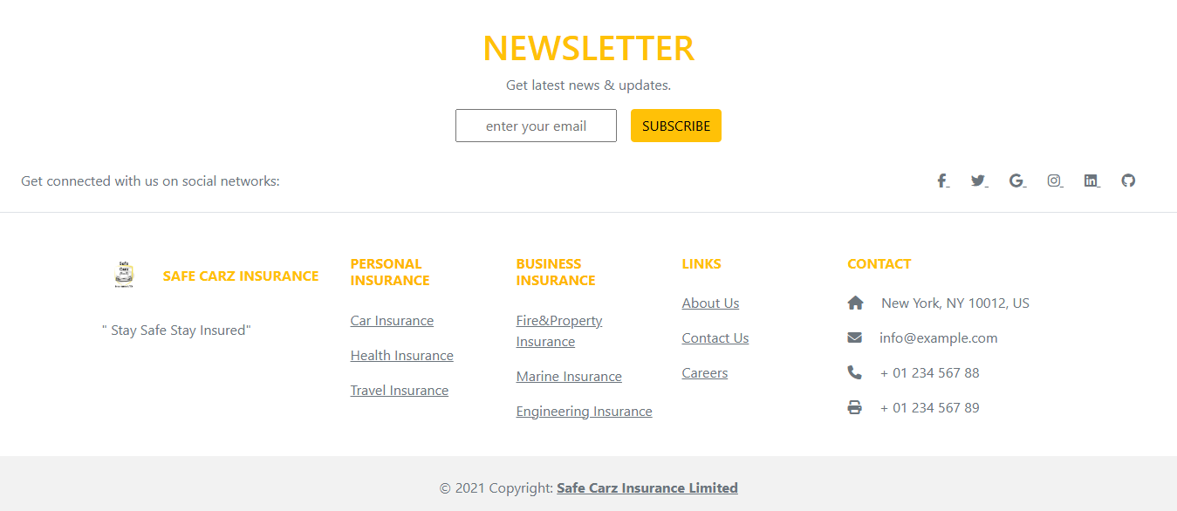This section is the **footer** of the Safe Carz Insurance website, providing essential information and navigation links for users. It includes:

**1. Newsletter Subscription**

Users can enter their email and click **"Subscribe"** to receive the latest news and updates about insurance services.

**2. Social Media Links**

Icons for various social networks allow users to stay connected with Safe Carz Insurance on different platforms.

**3. Insurance Categories**

The footer organizes services into:

* **Personal Insurance:** Car, Health, and Travel Insurance
* **Business Insurance:** Fire & Property, Marine, and Engineering Insurance

**4. Important Links**

Quick access to pages like **About Us, Contact Us, and Careers**, helping users explore company information or job opportunities.

**5. Contact Information**

Users can find the company's **address, email, and phone numbers** for direct communication.

This footer ensures easy navigation, engagement, and support for customers looking for insurance services.

ABOUT US:

here is about us page to inform you about our company.

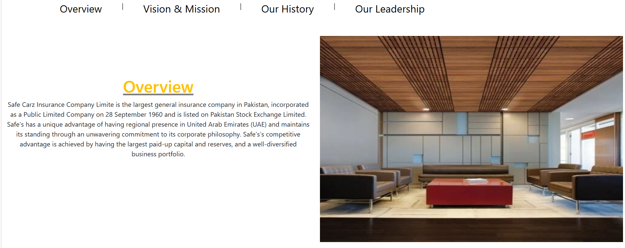

Over view of our website and history of our website.

Our setting and branches information.

Our services which we have deliverd.

CONTACT US:



Branches location you van visit our branches.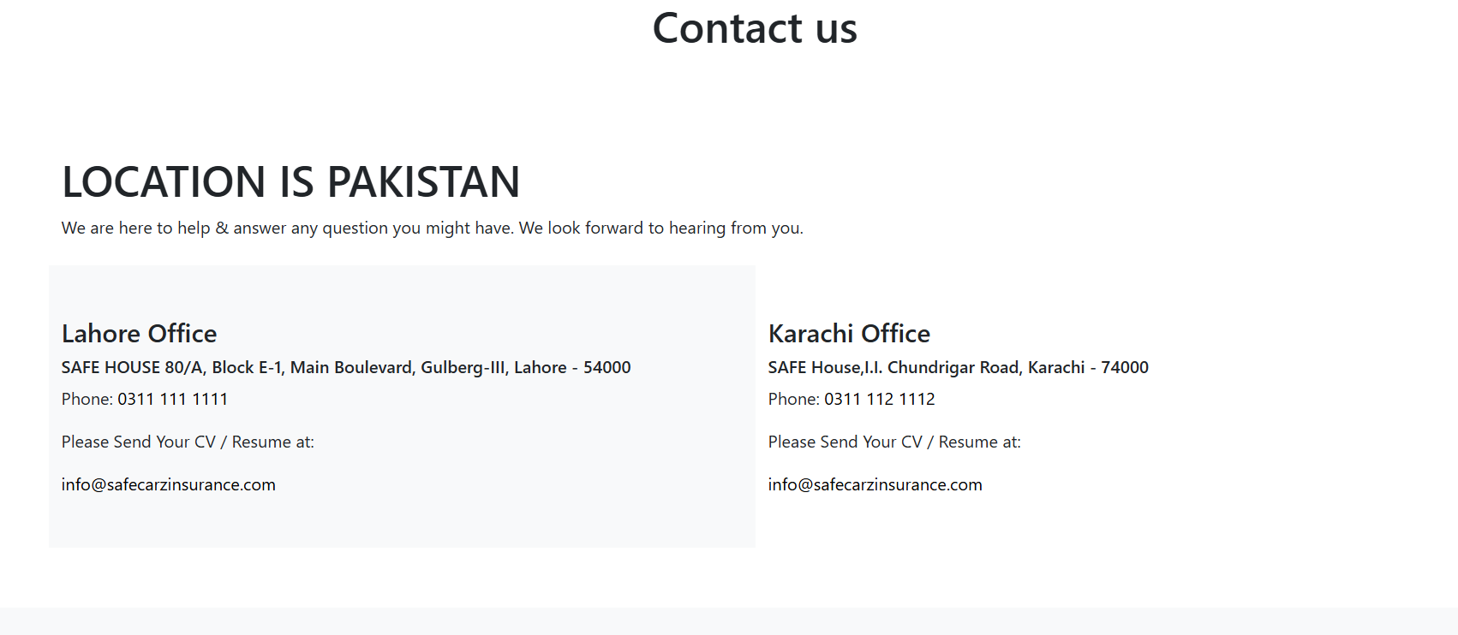

Or you can fill this form to contact us if you have any query.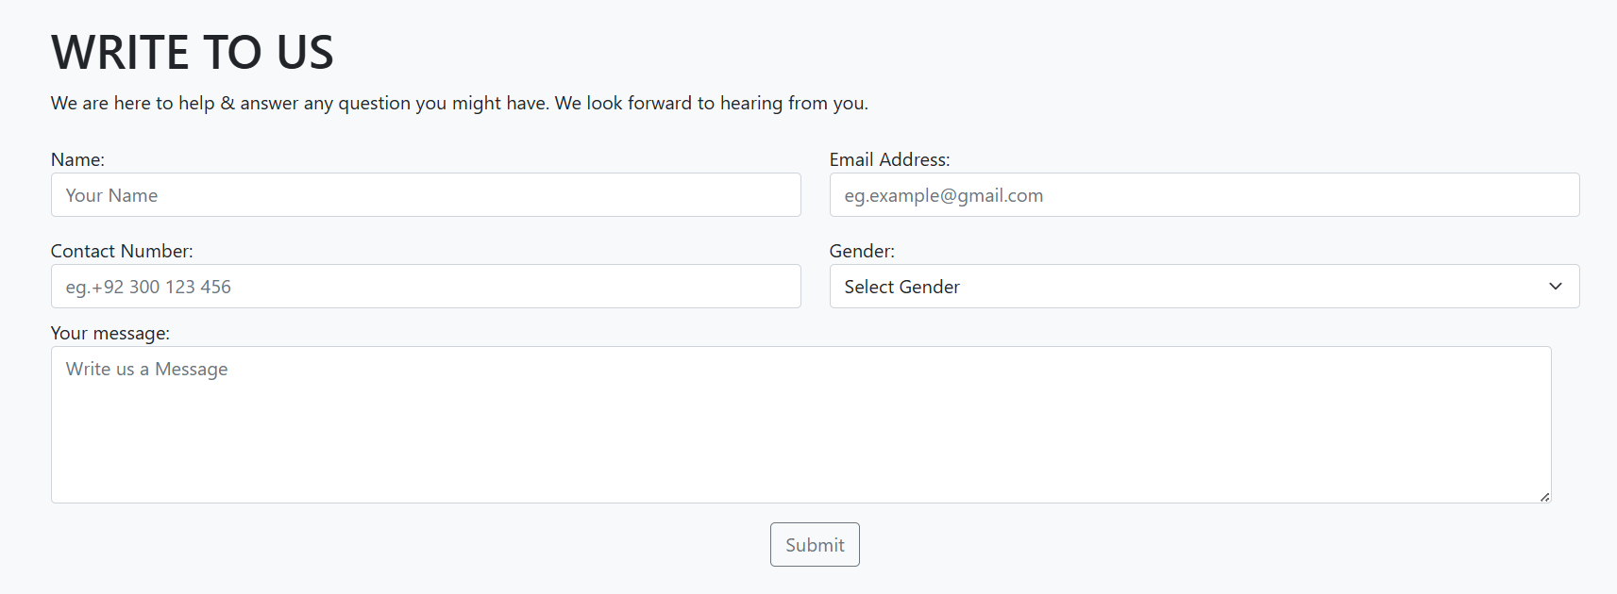

Phone numbers of call center branch network by clicking you cancntact with us.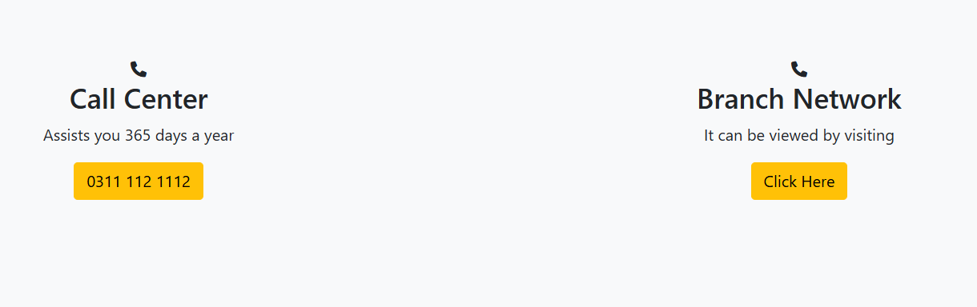

CAREER PAGE:

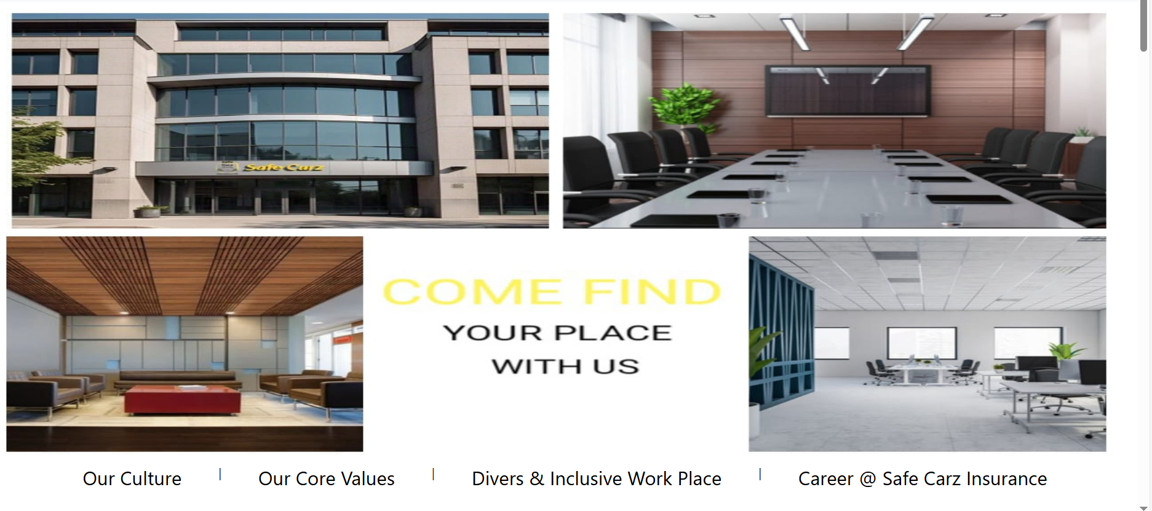

You can join us in this page you will get some information about our company .Our culture,Our History and our enviroment from which you will inpire and you hope to join our company.

LOGIN PAGE :

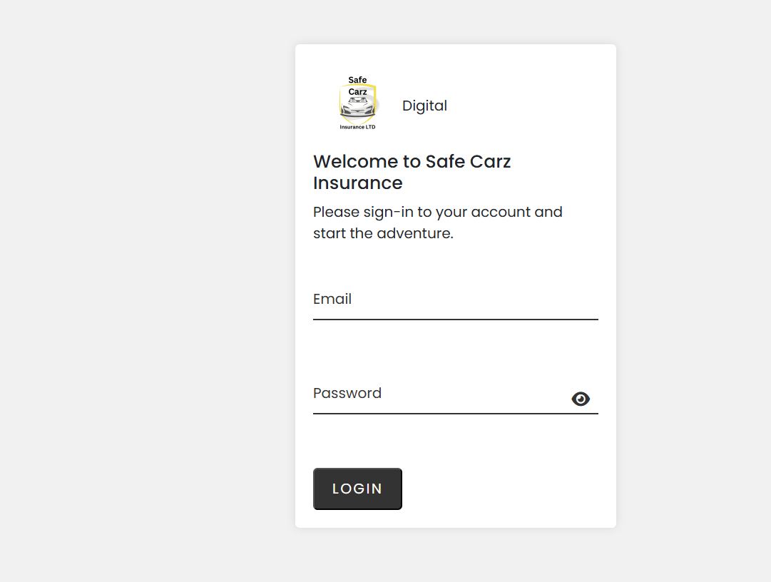

This is the login page for **Safe Carz Insurance Digital** platform. It allows users to sign in to their accounts and access insurance services. The page features a clean and minimalistic design with fields for **Email** and **Password**, along with a visible password toggle icon for better usability. The **"LOGIN"** button is prominently displayed for easy access. The text **"Please sign-in to your account and start the adventure."** adds a welcoming touch to the user experience.